**ACTIVITY: Diversion of Return water trough**

* Objective : - Safe work procedure for diversion of water trough
* Scope : - Blast Furnace Accessories
* Ref. : - VL/IMS/PID1/MECH/WI/22,SP44,SP31/
* Responsibility : - Engineer In charge and workmen on job

PPE’s to be used :

safety Helmet, Safety shoes, hand gloves, Dust mask, complete sealed goggle (As per the condition of the job), CO Monitor, Oxygen carriers, earplug during the usage of drill machine, compressor and concrete mixer and while carrying out the work. Sequence of jobs to be carried out

* Work No 1 : Fabrication of MS duct
* Work No 2 : Fixing of anchor bolt
* Work No 3 : Core cutting job

Aspect: Impact

Dust Generation Air pollution

Scrap generation Resource Depletion

Fire Air Pollution -SP42 Draining of water Resource depletion

Usage of LPG / oxygen Resource Depletion

Fumes of welding Air pollution & health

**Hazards identified: Ref:-SP31/REV.1.**

**A) Mechanical Hazard** –

1. Falling of hand gloves, working tools and materials inside return water tank while core cutting.
2. Bursting of water while core cutting for fixing fabricated MS duct and isolation of existing return water trough.
3. Fall of object on leg / body (bricks, tiles, phawda, shovel, pick axe, hammer, tools, etc).
4. Impact of material & machinery (slinged items, moving machineries, trucks, JCB, materials, mixer pan).
5. Slippage of pipe while handling.
6. Entanglement.
7. .
8. Impact of pneumatic hose of breaker due to failure of coupler/fitting.
9. Impact of pneumatic breaker due to slippage from hand.
10. Cut injuries from sharp edges of items
11. Failure of sling, chain pulley block.
12. Slip and fall due to slippery surface
13. Impact of compressed air due to compressed air line/hose burst
14. **Physical hazards** 
    1. Pressure due to failure of air /hydraulic system.
    2. Dust inhalation**.**
    3. Noise of compressor, Tap-hole drill machine, Breaker etc.
    4. **congestion**
15. **Electrical Hazard** –
    1. Shock due to usage of faulty wire connection for drilling machines and illumination bulbs.
    2. Shock due to welding machine, electrical cable
    3. Incidents due to poor illumination-visibility

**D) Chemical hazard**

1. Fire.
2. CO Gas poisoning.

**E) Human Behavior aspect of operators**:

Operator nature, alcoholism, casual approach, horse play, use of mobile at workplace, back pain & non usage of PPE?s

**SAFETY MEASURES**

1. 2 No’s of online CO monitor should be installed in addition to it at least 2 nos portable CO monitors to be used while working
2. Blowing area should be identified with help of Kerchief- Anemometer
3. Fan should be started to check for BF gas.
4. Mock drill for the person should be taken before starting work.
5. Sheet to be fitted around bottom trough to avoid gas movement in horizontal direction.
6. Sand bags to be placed in water trough on either side where core cutting will be done, to prevent water spillage.

**Work No 1: Fabrication of MS Launder**

1. Shift the structural material from the store following instructions given in the work procedure VL/IMS/PID1/MECH/WI/12
2. Plan cutting of material for maximum use of material in structure developed and least waste generation as scrap.
3. Carry out the cutting operation using gas-cutting set as per instruction give in SP 44.
4. Stack all the structure at proper place in safe condition so that it will not affect others.
5. Grind the sharp edges of the structure.
6. Carry out the welding operation as per design supplies in the form of drawing or as per instruction of engineer in charge.
7. Only trained operators should carryout grinding cutting and welding operation.
8. All temporary welded angles, channels etc has to be removed from site before giving clearance of job.
9. Carry out leakage test of installed launder by filling the entire launder with water. Check for any leakages & arrest the same.
10. Ensure proper housekeeping after completion of the job as per instruction VL/IMS/PID1/MECH/WI/91

**Work No 2: Fixing of anchor bolts**

1. Mark the points on the wall where anchor bolts need to be fixed as per the drawing.
2. Using the portable drill machine drill the holes to the required length and as per required size.
3. Once all holes are drilled fix the anchor bolts on the plate one by one.
4. Ensure that nut is tightened as per the requirement.

**Work No 3: Breaking job**

* 1. Skilled person should operate core cutting machine.
  2. Clamping should be done properly to the machine before start of the work.
  3. While breaking, breaker must ensure low dust generation by spraying water on earth surface to be attended.

**A) Procedure for core cutting in to the return water tank (Job can be carried out prior to shutdown during running hours of furnace)**

1. Take clearance from production SS
2. Take work permit for carrying out this activity and ensure that minimum 2 CO monitors are utilized while working with proper supervision.
3. Start the core cutting job as mentioned in work no.3
4. Once core cutting job is completed as per the drawing , kindly ensure that a temporary blind is provided to prevent any foreign particles like hand gloves or loose paper plastic etc. in to the return water tank which may get entrapped in to the pump.
5. Also kindly ensure that 2 nos. screen cloth are placed in to the return water trough at both the entry points.

**B) Procedure for main trough core cutting job**

**Note**: Job has to be carried out only on planned s/d day

1. Take clearance from HOD Production / Manager Production.
2. Request production dept. to minimize water in trough as much as possible, also divert tuyere /tuyere cooler outlet water between b/pipe no. 2 & 3.
3. Ensure that 2 nos. screens are placed in the MS trough as per its location.
4. Place sufficient double layered sand bags on either side of existing water trough where core cutting has to be done.
5. Now start core cutting job as mentioned in. Work no. 3
6. Once core cutting job is completed as desired then, check for water flow in to the return water tank via the MS trough by removing any one side sand bags which were earlier placed in the existing trough.
7. If water flow is found OK, then remove the other side sand bags
8. Check for any water leakage & arrest the same
9. Ensure that entire MS trough is covered with Aluminum sheet, to prevent any foreign particle entry into the trough

**Note: Incase there is any abnormality in the new trough then follow below mentioned procedure.**

* 1. Insert a pre fabricated MS plate cut to the size of trough in to the slots provided at the entry point of trough. Now try to provide 2-3 sand bags around these ms plates opposite to the side of main existing trough, to prevent water entry into the new ms trough.
  2. Additional sand bags or wooden wedges are to be provided around this ms plate in case of water leakage.

**C) Blanking of existing main trough water entry incase water is diverted via new MS trough**

1. Request production dept. to minimize water in trough as much as possible, also divert tuyere /tuyere cooler water near b/pipe no.4 & 5.
2. Place the pre fabricated MS plate at the entry point of trough.
3. Place 3-4 sand bags on both sides of ms plate. Small wooden wedges can be used to prevent minor leakages.
4. Start concreting job for open portion of the trough around the furnace.
5. Ensure no water leakage at joints b/t existing concrete and new concrete placed by applying quick setting cement.
6. Ensure that concrete mixer is having proper guards for moving parts.
7. For electrically operated mixer and vibrator, ensure certification from electrical department periodically. Only trained people should operate the mixer & vibrator.
8. Ensure that wooden planks (secured properly) are laid above reinforcement while concreting over reinforcement to avoid slip hazard.
9. Do not wear loose garments.
10. Cement and other materials left over must be properly stored in close cover it to reduce dust generation.
11. All waste cement must be properly diluted with water before discharge to environment.

# Do’s

* Ensure house keeping
* Clear all scraps & unwanted structures from platforms / work area
* Report damaged / corroded structures immediately
* Use co monitor while working in gas prone area.

Do Not;

Work under the influence of alcohol

Indulge in the Horse Play

Work alone in gas prone area.

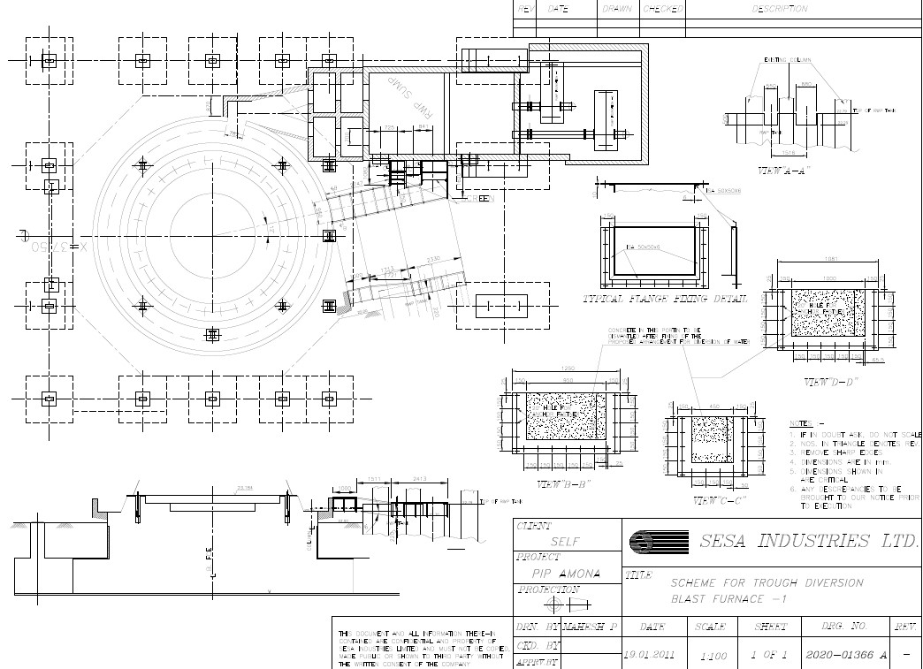

**Amendement Record**

|  |  |  |  |
| --- | --- | --- | --- |
| **Date** | **Manual Section Ref. & Para** | **Brief details of Revision** | **New Rev.** |
|  |  |  |  |
|  |  |  |  |
|  |  |  |  |

|  |  |  |
| --- | --- | --- |
| **Prepared By:**  Area Engineer | **Reviewed & Issued By:**  Management Representative | **Approved By:**  Mechanical Head |
| **Signature** | **Signature:** | **Signature:** |
| **Review Date: 12.12.22** | **Review Date: 12.12.22** | **Review Date: 12.12.22** |